Evan Wilson

CST-235

August 9th, 2018

Instructor: Dr. Toure

CLC Mini Project 1

Blue Group

GitHub Repo: <https://github.com/ewilson87/CST235_ewilson>

Question 1: How can configuration settings of a bean be made persistent?

A JavaBean can be made persistent through serialization. There are three ways of making a JavaBean serializable. The first and most common way is automatic serialization, which is implemented by the serializable interface, next is customized serialization by selectively selecting which parts to serialize, and lastly is customized file formatting implemented by the externalizable interface. Automatic serialization is done by making the JavaBean implement the Serializable interface, as shown in the Persistence class screenshots shown below.

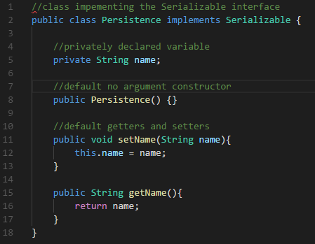

<https://docs.oracle.com/javase/tutorial/javabeans/advanced/persistence.html>

Question 2: What is the JavaBeans API?

The JavaBeans API (Application Program interface) is a set of classes and interfaces in the Java.beans package that provides the functionality to JavaBeans, similar to how any other API works. It is directed towards enterprise level applications and provides functionality for reusable software. Some of the included classes are converters, listeners and validators for use in development of beans. The JavaBeans API allows for long term persistence in writing and reading the state of the bean to non-volatile memory, and since it is a public API it should always remain functional. The reading and writing of beans is done in XML format using the XMLDecoder and XMLEncoder classes in the API.

<https://docs.oracle.com/javase/8/docs/api/java/beans/package-summary.html>

<http://openjdk.java.net/groups/swing/beans/index.html>